Test Plan for Charity Database Application

Introduction
This test plan will go through my testing strategy and the expected results for my database application. Ensuring that all my operations for donors, events, donations and all entities function correctly

Test 1: Adding Donor
This test ensures that a new donor can be successfully added. You must run the application, select Add Donor, Enter the necessary information then press Enter to save it.
Expected results: The donor is successfully added to the database
Actual Results:
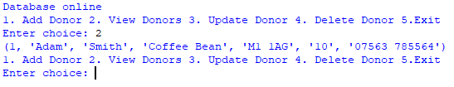
Figure 1 Donor adding successfully to the database
As shown within figure 1, A donor was successfully added to the database when following the instructions provided.

